Total 58 extensions can be found in the link below:

<https://marketplace.magento.com/extensions/shipping-fulfillment.html?>

**Germany specific address verification**

**Deutsche Post AG**

Access to the street directory based on the original postal routing data of Deutsche Post

<https://marketplace.magento.com/deutschepost-postdirekt-autocomplete.html>

**Pricing for Auto Complete service by Deutsche Post**

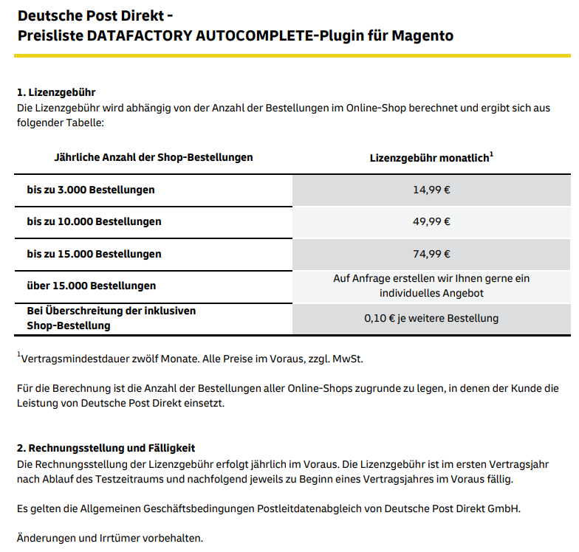

**International Solutions**

[**https://www.loqate.com/en-us/**](https://www.loqate.com/en-us/)

**Addressy** (New name Loqate)

Supports addresses in 245 countries. ASOS, Nescafe, IBM among 19k customers.

* Also includes Phone validation
* Upload address list in .CSV for validating current Address.

**Test**

<https://www.loqate.com/en-gb/address-verification/address-capture/>

**Setup Guide**

<https://www.loqate.com/resources/support/setup-guides/magento-2/?rd=pca>

**Pricing for Addressy**

Free trial with 100USD credit. And subscriptions starts at 75eur per year.

**Google Maps Auto Complete**

[**https://developers-dot-devsite-v2-prod.appspot.com/maps/documentation/javascript/examples/places-autocomplete-addressform**](https://developers-dot-devsite-v2-prod.appspot.com/maps/documentation/javascript/examples/places-autocomplete-addressform)

This solution requires some development skills to integrate.

As I understood 10k requests per month is free. Then billed 2USD per 1k request.

Error prevention is not sufficient. The user can still fill in wrong information.

Example application:

<https://developers-dot-devsite-v2-prod.appspot.com/maps/documentation/javascript/examples/full/places-autocomplete-addressform>

